Semester Two Examination, 2013

Question/Answer Booklet

STAGE 3AB CHEMISTRY

Students NaME:____________________________

TEACHERS NAME:____________________________

Marks | Actual | % Mark
Sec I : M/C | / 50
Sec II short  answer | / 70
Sec III Extended | / 80
 |  | 200

Time allowed for this paper
Reading time before commencing work: ten minutes
Working time for paper: three hours

Material required/recommended for this paper

To be provided by the supervisor
This Question/Answer booklet
Multiple-choice Answer sheet
Chemistry Data sheet

To be provided by the candidate
Standard items: pens (blue/black preferred), pencils, sharpener, correction fluid/tape, eraser, ruler, highlighters

Special items: non-programmable scientific calculators approved for use in the WACE examinations

Important note to candidates
No other items may be taken into the examination room. It is your responsibility to ensure that you do not have any unauthorised notes or other items of a non-personal nature in the examination room. If you have any unauthorised material with you, hand it to the supervisor before reading any further.
Structure of this paper

Section | Number of questions available | Number of questions to  Be answered | Suggested  working time  (minutes) | Marks  available | Percentage  of exam
Section One:  Multiple-choice | 25 | 25 | 50 | 25 | 25
Section Two:  Short answer | 8 | 8 | 55 | 70 | 35
Section Three:  Extendedanswer | 6 | 6 | 70 | 80 | 40
 |  |  |  | Total | 100

Instructions to candidates

- The rules for the conduct of Western Australian external examinations are detailed in the Year 12 Information Handbook 2013. Sitting this examination implies that you agree to abide by these rules.

- Answer the questions according to the following instructions.

Section One:Answerall questions on the separate Multiple-choice Answer sheet provided.For each question shade the box to indicate your answer. Use only a blue or blackpen to shade the boxes. If you make a mistake, place a cross through that square then shade your new answer. Do not erase or use correction fluid/tape. Marks will not be deducted for incorrect answers. No marks will be given if more than one answer is completed for any question.

Sections Two and Three:Write your answers in this Question/Answer Booklet.

- When calculating numerical answers, show your working or reasoning clearly. Express numerical answers to three significant figures and include appropriate units where applicable.

- You must be careful to confine your responses to the specific questions asked and to follow any instructions that are specific to a particular question.

- Spare pages are included at the end of this booklet. They can be used for planning your responses and/or as additional space if required to continue an answer.

- Planning: If you use the spare pages for planning, indicate this clearly at the top of the page.
- Continuing an answer: If you need to use the space to continue an answer, indicate in the original answer space where the answer is continued, i.e. give the page number. Fill in the number of question(s) that you are continuing to answer at the top of the page.

- The Chemistry Data Sheet is not handed in with your Question/Answer Booklet.
Section One: Multiple-choice 25% (50 marks)

This section has 25 questions. Answer all questions on the separate Multiple-choice Answer Sheet provided. For each question shade the box to indicate your answer. Use only a blue or black pen to shade the boxes. If you make a mistake, place a cross through that square then shade your new answer. Do not erase or use correction fluid/tape. Marks will not be deducted for incorrect answers. No marks will be given if more than one answer is completed for any question.

Suggested working time: 45 minutes.

- An element, X , was found to have the following successive ionisation energies:

Ionisation | 1st | 2nd | 3rd | 4th | 5th | 6th | 7th | 8th
Ionisation energy/kJ mol⁻¹ | 736 | 1450 | 7740 | 10500 | 13600 | 18000 | 21700 | 25600

Which of the following represents the most likely formula for the sulphate of X?

- XSO₄
- X₂SO₄
- X₂(SO₄)₃
- X(SO₄)₂

- Which of the following bonds would be expected to have the greatest polarity (i.e. most polar?)

- N–F
- P–F
- S–F
- O–F

- Carbon, silicon, germanium, tin, and lead are all placed together in the same group of the periodic table because:

- They have the same number of valence electrons.
- Each has a structural form with delocalized electrons.
- Atoms of each element have the same number of electrons.
- There is a gradual increase in their atomic masses.

- Arsenic has 23 isotopes, the lightest of which is ⁶⁵As.Which of the following correctly lists the number of subatomic particles in the arsenide (⁶⁵As³⁻) ion?

- 65 protons, 33 neutrons and 68 electrons
- 33 protons, 32 neutrons and 30 electrons
- 65 protons, 32 neutrons and 65 electrons
- 33 protons, 32 neutrons and 36 electrons
- Place the following substances in order of melting point, starting with the lowest:

Na₂O(s), SO₂(s), O₂(s), SiO₂(s)

- SO₂(s) O₂(s) Na₂O(s) SiO₂ (s)
- SO₂(s) O₂(s) SiO₂ (s) Na₂O(s)
- O₂(s) SO₂(s) Na₂O(s) SiO₂ (s)
- O₂(s) SO₂(s) SiO₂ (s) Na₂O(s)

- Which of the following statements about carbon dioxide, nitrogen dioxide, and sulfur dioxide
is /are true?

- They are all covalently bonded molecules
- They all have the same total number of electrons
- They all have double bonds
- They all have the same number of bonding pairs of electrons

- (i) and (iii) only
- (ii) and (iv) only
- (i), (iii) and (iv) only
- (i), (ii), (iii) and (iv)

- Which one of the following molecules has a linear shape?

- CH₄
- H₂Se
- CS₂
- NH₃

- Predict which of the following has the greatest solubility in water.

- propanoic acid
- propan-1-ol
- silver iodide
- magnesium phosphate

- Predict which one of the following aqueous solutions is the best conductor of electricity.

- 1.00 molL⁻¹ethanoic acid
- 1.00 molL⁻¹ammonia
- 1.00 molL⁻¹calcium chloride
- 1.00 molL⁻¹nitric acid

- The solubility of oxygen in seawater at 20°C is 14.4 mg L⁻¹. Which of the following is the maximum concentration of oxygen in seawater, given in mol L⁻¹, at this temperature?

- 4.5 x 10⁻¹mol L⁻¹
- 9.0 x 10⁻¹mol L⁻¹
- 4.5 x 10⁻⁴mol L⁻¹
- 9.0 x 10⁻⁴mol L⁻¹

- Which of the following contains the largest number of atoms?

- 6.022 x 10²² molecules of methane
- 0.24 mol of argon gas
- 12 L of nitrogen gas at standard temperature and pressure (STP)
- 10 g of nitrogen monoxide

- The sign of ∆H for the process:

H₂O() H₂O(s)

- is positive and the reaction is endothermic.
- is positive and the reaction is exothermic.
- is negative and the reaction is endothermic.
- is negative and the reaction is exothermic.

- Which of the following statements about the effect of a catalyst is false?

- A catalyst increases the proportion of particles possessing sufficient energy to react.
- A catalyst increases the energy of reactants, enabling them to collide with enough energy to react.
- A catalyst provides an alternative reaction pathway.
- A catalyst is not consumed in a reaction.

- Which of the following lists the 1 mol L⁻¹ solutions in of increasing pH?

(a) CH₃COOH(aq), NH₄C(aq), NaC(aq). CH₃CH₂NH₂(aq)

(b) CH₃COOH(aq), NaC(aq), NH₄C(aq), CH₃CH₂NH₂(aq)

(c) CH₃CH₂NH₂(aq), NaC(aq),, NH₄C(aq),CH₃COOH(aq)

(d) NH₄C(aq), CH₃COOH(aq),CH₃CH₂NH₂(aq),NaC(aq)

- During an experiment to establish the concentration of an oxalic acid solution, a student carried out the following steps.

- Rinsed a burette with distilled water.
- Rinsed a conical flask with distilled water.
- Filled the burette with a standardised sodium hydroxide solution.
- Rinsed a pipette with the solution of oxalic acid.
- Dispensed 25 mL of oxalic acid into the conical flask using the pipette.

What effect would her procedure have had on the accuracy of her results?

- An artificially large volume of sodium hydroxide is needed to reach the end point, and the calculated concentration of oxalic acid would have been too low.
- An artificially small volume of sodium hydroxide is needed to reach the end point, and the calculated concentration of oxalic acid would have been too low.
- An artificially large volume of sodium hydroxide is needed to reach the end point, and the calculated concentration of oxalic acid would have been too high.
- An artificially small volume of sodium hydroxide is needed to reach the end point, and the calculated concentration of oxalic acid would have been too high.

- What would be the most likely pH of a 0.10 mol L⁻¹ solution of sulfuric acid?

- Less than 0.7
- Between 0.7 and 1
- Exactly 1
- Approximately 1.5

The next three questions (17, 18 and 19) refer to the following reaction between phosphorus trichloride and chlorine to form phosphorus pentachloride:

PC₃(g) + C₂(g) PC₅ (g) ΔH = -124 kJ mol⁻¹

- If phosphorus trichloride and chlorine were placed in a sealed insulated vessel together with a catalyst, which of the following would not cause an increase in the rate at which equilibrium would be attained?

- Increasing the volume of the vessel
- Increasing the temperature
- The addition of chlorine to the reaction mixture
- Increasing the state of sub-division of the catalyst

- Which of the following statements is/are true when the system is at equilibrium?

- Reactants are no longer turning into products.
- The concentration of chlorine in the vessel is constant.
- Adding a catalyst would not affect the proportions of the reaction mixture.

- (iii) only
- (i) and (ii) only
- (ii) and (iii) only
- (i), (ii) and (iii)

- Which of the following changes would not be observed once equilibrium is re-established if a little phosphorus trichloride gas was added at constant temperature to an equilibrium mixture containing the three gases in the equation?

- The reverse reaction would speed up.
- The concentration of phosphorus trichloride would increase.
- The mass of chlorine in the vessel would fall.
- The value of the equilibrium constant, K, would fall.

- Which of the following equations does not represent a redox reaction?

- Mg(s)+ 2 HC(aq) MgC₂(aq) + H₂(g)
- Mg(OH)₂(s) + 2 CH₃COOH(aq) Mg(CH₃COO)₂(aq) + 2 H₂O()
- Sn²⁺(aq) + Zn(s) Sn(s) + Zn²⁺(aq)
- CH₄(g) + 2 O₂(g) CO₂(g) + 2 H₂O(g)

- A piece of cobalt is placed into a solution of copper (II) sulfate. Which of the following statements is false?

- Copper is precipitated.
- There is no change in the number of charged particles in solution.
- Cobalt dissolves.
- Copper ions are oxidized.

- Which of the following metals, when placed in a solution of nickel (II) sulfate, would cause the solution to fade from green to colourless?

- Lead
- Zinc
- Chromium
- Iron

- Consider the following molecule, commonly known as oil of wintergreen:

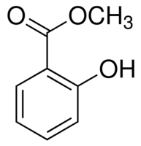
oil of wintergreen

Which of the following statements about oil of wintergreen is false?

- It can be synthesised using methanol as one of the starting materials.
- It is an aldehyde.
- It is unsaturated.
- It is an ester.

- Which of the following molecules can be classified as secondary alcohols?

- 2-methylpropan-2-ol
- 3-methylbutan-2-ol
- CH₃CHO
- CH₃COCH₃

- (i) and (ii) only
- (ii) only
- (ii), (iii) and (iv) only
- (ii) and (iv) only

- The following formula represents the structure of a compound commonly used as a detergent:

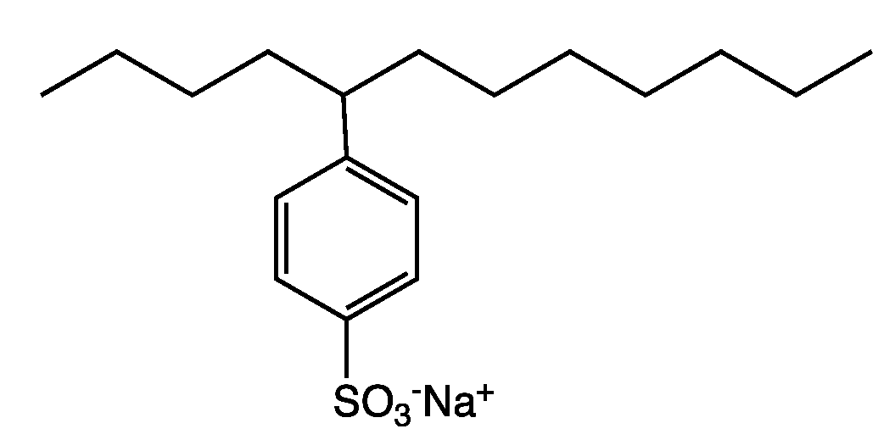

Which of the following statements about detergents is false?

- They are often preferred to soaps because of their low tendency to form scum with hard water.
- Part of the molecule is highly water-soluble.
- They are the sodium salts of carboxylic acids.
- The molecules contain large non-polar regions that can form intermolecular forces with fats.

End of section one

Belmont City College

MULTIPLE CHOICE ANSWER SHEET

CHEMISTRY 12 SEMESTER 2 EXAMINATION 2013

Name: __________________________ Teacher: _____________________________

For each question, shade the box to indicate your answer. Use only a blue or black pen to shade the boxes. For example, if b is your answer: a  b c d

If you make a mistake, place a cross through that square, do not erase or use correction fluid.
Shade your new answer.
X

For example, if b is a mistake and d is your correct answer: a b c d

In the event that you then change your mind back to your original answer, you then cross out the second selection and then circle the first choice.
o

For example, if b was the first choice and d your second, but you changed your mind back,
X
and b is your correct answer:
X
a b c d

Multiple Choice: Mark the answer by shading in the box to the LEFT of the letter you chose.

14. a b c d

15.a b c d

16.a b c d

17. a b c d

18. a b c d

19. a b c d

20. a b c d

21. a b c d

22. a b c d

23. a b c d

24.a b c d

25. a b c d
1. a b c d

2. a b c d

3. a b c d

4. a b c d

5. a b c d

6. a b c d

7. a b c d

8. a b c d

9. a b c d

10. a b c d

11. a b c d

12. a b c d

13. a b c d

Section Two: Short answer 35% (70 Marks)

This section has eight (8) questions. Answer all questions. Write your answers in the space provided.

When calculating numerical answers, show your working or reasoning clearly. Express numerical answers to three significant figures and include appropriate units where applicable.

You can use abbreviations, such as ‘nvr’ for ‘no visible reaction’.

Spare pages are included at the end of this booklet. They can be used for planning your responses and/or as additional space if required to continue an answer.
- Planning: If you use the spare pages for planning, indicate this clearly at the top of the page.
- Continuing an answer: If you need to use the space to continue an answer, indicate in the original answer space where the answer is continued, i.e. give the page number. Fill in the number of the question(s) that you are continuing to answer at the top of the page.

Suggested working time: 60 minutes.

Question 26 (8 marks)
For each of the following pairs of substances, provide details of a chemical test that would allow the two substances to be distinguished from one another. Equations are not required.

substances | chemical test | Observations
Ni(s) and Mg(s) |  | Ni(s)
 |  | Mg(s)
NaCH₃COO(s) and NaC(s) |  | NaCH₃COO(s)
 |  | NaC(s)

Question 27 (8 marks)

- 2-methylpropanal, whose formula is (CH₃)₂CHCHO, has many structural isomers. In the spaces provided below, draw the full structure and give the IUPAC names of two isomers.
(4 marks)

Structure | IUPAC name

2-methylpropanal can be converted into substance Y by heating it with a mixture of sodium dichromate and dilute sulfuric acid.

- State an observation that can be made as this reaction proceeds. (1 mark)

____________________________________________________________________________
____________________________________________________________________________
- Name the functional group present in substance Y that is not present in 2-methylpropanal.
(1 mark)

____________________________________________________________________________

- Write a balanced half-equation showing the conversion of 2-methylpropanal into substance Y
(2 marks)

_____________________________________________________________________________

Question 28 (11 marks)

A student wishing to investigate the oxidising strength of various metals set up an electrochemical cell made up of a copper rod immersed in a solution of copper (II) sulfate and a magnesium rod immersed in a solution of magnesium nitrate. The apparatus used is shown in the diagram below.
CuSO₄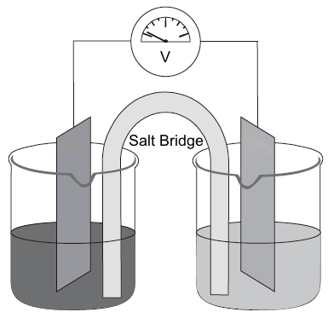 Mg(NO₃)₂
Magnesium
Copper

- Clearly label the anode on the diagram above. (1 mark)

- By adding an arrow to the diagram, show the direction of electron flow in the external circuit.
(1 mark)

- Give the half equation for the reaction occurring at the positive electrode. (1 mark)

____________________________________________________________________________

- Give the name or formula of a suitable substance that the salt bridge might contain. (1 mark)

______________________________________________________________________________

- State the reducing agent (reductant) in the cell. (1 mark)

______________________________________________________________________________

Question 28 (contd)

- The initial voltage measured in the cell was higher than the 2.70 V that the student had expected to measure. Give two possible reason for this observation. (2 marks)

____________________________________________________________________________________________________________________________________________________________

- Describe two observation that would be expected to be made in the copper half-cell whilst the experiment was taking place. (2 marks )

____________________________________________________________________________________________________________________________________________________________

Rusting can be described as the formation of iron (III) hydroxide from iron in the presence of water and oxygen. Rusting can be prevented by attaching magnesium to the object that is to be protected.

- With reference to the list of redox potentials found on your data sheet, explain why magnesium is a suitable material for this purpose. (2 marks)

____________________________________________________________________________________________________________________________________________________________
______________________________________________________________________________
______________________________________________________________________________
______________________________________________________________________________
______________________________________________________________________________

Question 29 (9 marks)

For each species listed in the table below, draw the Lewis structure, representing all valence shell electron pairs either as : or as — and state or sketch the shape of the species.

(for example, water) |  |  |  |  |  |  |  | (bent, polar)
Species | Lewis structure (showing all valence electrons) |  |  |  |  |  | Shape (sketch or name)
phosphorus
trichloride

PC₃
methanal

HCHO
nitrate ion

NO₃⁻

Question 30 (10 marks)

By referring to the structure and/or bonding present, account for the following:

(a) Soaps can dissolve both polar and non polar solutes
(4 marks)

____________________________________________________________________________________________________________________________________________________________________________________________________________________________________________________________________________________________________________________________________________________________________________________________________________________________________________________________________________________
______________________________________________________________________________

______________________________________________________________________________

(b) Aluminium is a better conductor of electricity than magnesium. (2 marks)

________________________________________________________________________________________________________________________________________________________________________________________________________________________________________________________________________________________________________________________
(c) Silicon dioxide (SiO₂) is a solid with an extremely high melting point, whilst carbon dioxide (CO₂) sublimes at -78°C. (4 marks)

________________________________________________________________________________________________________________________________________________________________________________________________________________________________________________________________________________________________________________________________________________________________________________________________________________________________________________________________________________________________________________________________________________________________________________________________________________________________________________
Question 31 (7 marks)
- But-1-ene and but-2-ene are isomers of one another. What is the name given to this type of isomerism? (1 mark)

____________________________________________________________________________

- In addition to the type of isomerism displayed by the molecules in part (a), but-2-ene itself exhibits another type of isomerism. State the name given to this type of isomerism, and identify the features of but-2-ene that make this type of isomerism possible. (3 marks)

__________________________________________________________________________________________________________________________________________________________________________________________________________________________________________

- In the space provided, draw a length of polymer chain that could be formed from 2-butene, showing three repeating units. (2 marks)

- State the name given to the type of polymerisation described in part (c). (1 mark)

____________________________________________________________________________

Question 32 (7 marks)

- Nitrous acid (HNO₂) is a weak acid. Use relevant equations to explain how you would expect the pH of a 0.1 mol L⁻¹ solution of nitrous acid to compare with that of a 0.1 mol L⁻¹ solution of nitric acid. (3marks)

__________________________________________________________________________________________________________________________________________________________________________________________________________________________________________
______________________________________________________________________________

A titration is carried out using 25.00 mL of approximately 0.9 molL⁻¹ ammonia solution placed in a conical flask. A few drops of indicator are added, and 0.900 mol L⁻¹nitric acid is added from a burette.

The table below shows some indicators, together with their pH ranges, and their colours.

indicator name | pH range | colour in acid | Colour in base
methyl yellow | 2.9 – 4.0 | Red | Yellow
bromothymol blue | 6.0 – 7.6 | Yellow | Blue
nile blue | 10.1 – 11.1 | Blue | Red
Nitramine | 11.0 – 13.0 | Colourless | Orange

- From the indicators shown in the table, choose one that would be suitable for the titration, and state the colour change that would be expected to occur. (2 marks)

Indicator: ______________________________________________________________
Colour change: ______________________________________________________________

When approximately 12.5 mL of nitric acid have been added, the solution in the flask can be classified as a buffer solution.

- With the aid of equations, explain how the solution is able to act as a buffer. (2 marks)

__________________________________________________________________________________________________________________________________________________________________________________________________________________________________________
__________________________________________________________________________________________________________________________________________________________________________________________________________________________________________

Question 33 (10 marks)

When ethanol and ethanoic acid are mixed together in concentrated sulfuric acid, the following reversible reaction occurs:

CH₃CH₂OH (aq) + CH₃COOH (aq) CH₃CH₂OOCCH₃ (aq) + H₂O ()

- Identify the type of reaction taking place in the forward direction, and give the IUPAC name of the organic product. (2 marks)

Type of reaction: ______________________________________________________________
Name of product: ______________________________________________________________

- Write an expression for the equilibrium constant, K, for the reaction in the space provided.
(1 mark)

- The reaction is usually carried out at high temperatures in order to increase the yield. State and explain what this tells us about the enthalpy (Н_{p}) of the products compared to the enthalpy (Н_{R})of the reactants. (3 marks)

______________________________________________________________________________
__________________________________________________________________________________________________________________________________________________________________________________________________________________________________________
______________________________________________________________________________
______________________________________________________________________________
________________________________________________________________________________________________________________________________________________________________________________________________________________________________________________

Question 33 (cont’d)

A titration can be used to determine the proportions of reactants and products present at equilibrium.

Although the addition of sodium hydroxide does disturb the equilibrium, the inaccuracy introduced is small if the reaction mixture is cooled immediately prior to titration.

- State the effect of addition of sodium hydroxide to the equilibrium mixture on the value of the equilibrium constant, K, by circling the correct answer below. (1 mark)

Effect on K (circle one) | INCREASE | DECREASE | NO CHANGE

(e) On the axes shown below sketch the effect of cooling the reaction mixture (t₁) on the rates of the forward and backward reactions until the system returns to a new equilibrium (t₂).( 3 marks)

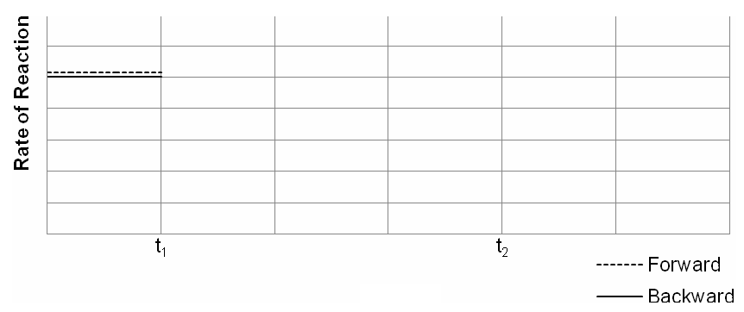

End of section two
Section Three: Extended answer 40% (80 marks)

This section contains six(6) questions. Answer all questions. Write your answers in the spaces provided.

Where questions require an explanation and/or description, marks are awarded for the relevant
chemical content and also for coherence and clarity of expression.

Final answers to calculations should be expressed to three (3) significant figures.

Spare pages are included at the end of this booklet. They can be used for planning your
responses and/or as additional space if required to continue an answer.

- Planning: If you use the spare pages for planning, indicate this clearly at the top of the page.
- Continuing an answer: If you need to use the space to continue an answer, indicate in the
original answer space where the answer is continued, i.e. give the page number. Fill in the
number of the question(s) that you are continuing to answer at the top of the page.
Suggested working time:70 minutes.

Question 34 (13 marks)
Chlorine is found in acids of various strengths. Chlorine can exist in different oxidations states. Some acids are shown in the table below.

Name and formula of acid | Strong/Weak
hydrochloric acid  HC | Strong
hypochlorous acid  HOC | Weak
chlorous acid  HCO₂ | Weak
chloric acid  HCO₃ | Strong
perchloric acid  HCO₄ | Strong

- What mass of perchloric acid would need to be dissolved in 250 mL of distilled water to produce a solution with a pH of 3.59? (3 marks)

____________________________________________________________________________________________________________________________________________________________
____________________________________________________________________________________________________________________________________________________________

Question 34

2.78 g of solid barium hydroxide was added to a beaker containing 200 mL of a 0.160 mol L⁻¹ aqueous solution of chloric (HClO₃) acid, and the solution stirred until all the solid had dissolved. The product formed is soluble.

- Write a balanced ionic equation to show the reaction taking place in the beaker. (2 marks)

____________________________________________________________________________

- Determine the limiting reagent by calculation. (4 marks)

______________________________________________________________________________
________________________________________________________________________________________________________________________________________________________
______________________________________________________________________________
______________________________________________________________________________
____________________________________________________________________________________________________________________________________________________________
______________________________________________________________________________
______________________________________________________________________________

- Calculate the pH of the resulting solution. (4 marks)

______________________________________________________________________________
______________________________________________________________________________
____________________________________________________________________________________________________________________________________________________________
______________________________________________________________________________
______________________________________________________________________________
______________________________________________________________________________

This page has been intentionally left blank

Question 35 (18 marks)

Solutions of iron(II) salts are often used in redox titrations, but can be problematic as the Fe²⁺ ions can be oxidised by oxygen in the environment, forming various hydrated forms of iron(III) oxide, according to the following rusting equation:

Fe²⁺(aq) + O₂(g) + (2 + 4) H₂O() 2 Fe₂O₃.H₂O(s) + 8H⁺(aq)

Ammonium iron (II) sulfate, or Mohr’s salt, is often preferred over iron(II) sulfate for redox titration purposes since the unwanted oxidation of Fe²⁺ is prevented by the ammonium ions present (which also reduces the pH of the solution). Mohr’s salt is commonly found in hydrated form, as any of a number of salts with the formula (NH₄)₂Fe (SO₄)₂.H₂O.

- Write a hydrolysis equation to show how the ammonium ions are able to lower the pH of the
solution. (2 marks)

____________________________________________________________________________

- Use the rusting equilibrium reaction above to explain why the oxidation of Fe²⁺ is prevented in solutions of low pH. (2 marks)

____________________________________________________________________________
____________________________________________________________________________
____________________________________________________________________________
10.0 g of hydrated ammonium iron(II) sulfate crystals were dissolved in distilled water and made up to 250.0 mL in a volumetric flask.
25.0 mL aliquots of this solution were titrated against 0.0240 mol L⁻¹ potassium permanganate solution until consistent results were obtained. The table below shows the results of the experiment.

 | Rough | 1 | 2 | 3 | 4
Final volume (mL) | 23.00 | 21.25 | 21.25 | 22.65 | 23.35
Initial volume (mL) | 0.00 | 0.05 | 0.00 | 0.10 | 2.10
Titre or Titration volume (mL)

- Complete the table and calculate the average titration volume. (1 mark)

Average titre: ______________________________________________________________

Question 35 (continued)

- Write an overall (net) balanced ionic equation for the titration reaction taking place.
(3 marks)

____________________________________________________________________________
____________________________________________________________________________
____________________________________________________________________________

(e) Calculate the number of moles Fe ²⁺present in the 250.0 mL volumetric flask.
(4 marks)

(f) Determine the mass of non-hydratedMohr’s salt present in 250.0 mL (3 marks)

(g) Calculate the value of in the formula (NH₄)₂Fe(SO₄)₂.H₂O. (3 marks)

Question 36 (10 marks)

A sample of powdered magnesium sulfate is known to have been contaminated with sodium chloride. The percentage purity of the magnesium sulfate can be determined by the following method:

- 32.50 g of the impure magnesium sulfate is dissolved in water and the solution is made up to 500.0 mL in a volumetric flask.
- Six 20.0 mL aliquots of this solution are placed in separate conical flasks.
- Different volumes of 0.100 mol L⁻¹BaC₂(aq) are added to each flask, causing any sulfate ion present to precipitate out of the solution.
- The precipitate from each sample is filtered, rinsed with distilled water and then dried to constant mass.

The results of this analysis are shown in the table below.

Sample | 1 | 2 | 3 | 4 | 5 | 6
Volume of BaC₂(aq) added(mL) | 30.0 | 60.0 | 90.0 | 120.0 | 150.0 | 180.0
Mass of BaSO₄(s) precipitated(g) | 0.61 | 1.23 | 1.83 | 2.04 | 2.04 | 2.04

- Graph the results in a suitable format using the axes provided. (2 marks)
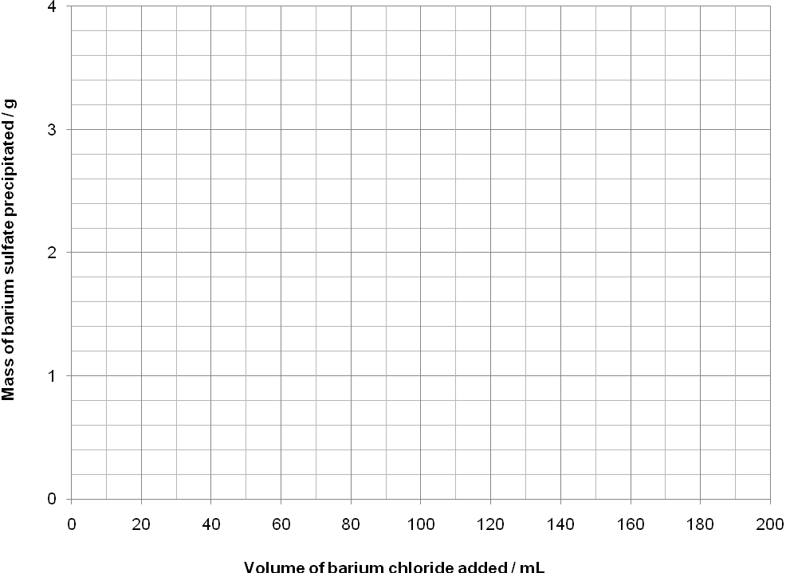

Question 36

- Write a balanced ionic equation for the reaction taking place. (1 mark)

____________________________________________________________________________

- Explain why the mass of precipitate remained constant for the last three samples, in spite of the fact that more barium chloride was being added. (1 mark)

____________________________________________________________________________
____________________________________________________________________________
(d)Use the graph you have drawn in part (a) to estimate the minimum volume of barium chloride needed to precipitate all the sulfate ions from solution. (1 mark)

____________________________________________________________________________

(e ) Use the mass of precipitate to calculate the percentage purity of the magnesium sulfate.
(5 marks)

____________________________________________________________________________
____________________________________________________________________________
____________________________________________________________________________
____________________________________________________________________________
____________________________________________________________________________
____________________________________________________________________________
____________________________________________________________________________
____________________________________________________________________________
____________________________________________________________________________
____________________________________________________________________________
____________________________________________________________________________
____________________________________________________________________________
____________________________________________________________________________
____________________________________________________________________________
____________________________________________________________________________

Question 37 (12 marks)

Commercial caustic soda contains both sodium hydroxide and sodium carbonate. A year 12 student wants to determine the percentage by mass of sodium carbonate in caustic soda. She dissolves 2.487gof the solid, transfers it carefully to a 250.0 mL volumetric flask, and adds distilled water to the mark.

She then pipettes 25.0 mL of this solution into a conical flask and titrates it against standard
0.9331mol L⁻¹hydrochloric acid using methyl orange indicator. The average volume of the acid added from the burette was 21.34 mL. In this case hydrochloric acid reacts with all the carbonate and hydroxide ions present in the conical flask.

She pipettes another 25.0 mL of the diluted caustic solution from the volumetric flask and places it into another separate conical flask. She warms the conical flask and its contents to 70◦C and slowly adds 1%barium chloride solution until no more precipitate is formed. This process removes all the carbonate ions by precipitating them out as barium carbonate. She cools the solution, adds a few drops of phenolphthalein indicator to it and titrates it against the 0.9331 mol L⁻¹hydrochloric acid. The average volume of hydrochloric acid from the burette was 19.82 mL. In this case the hydrochloric acid only reacts with hydroxide ions in solution.

Show all working out steps clearly to score full allocated marks. Express your answer correct to three significant figures.

(a) The number of moles of hydrochloric acid that would be required to neutralise all of the carbonate and hydroxide ions present in 250.0 mL volumetric flask. (2 marks)

(b) The number of moles of sodium hydroxide present in 250.0 mL volumetric flask. (3 marks)

(c) The mass of sodium carbonate present in 250.0 mL solution. (5 marks)

- What percentage by mass of sodium carbonate in the caustic soda will her results give?
(2 marks)

Question 38 (10 marks)

The functional groups present in organic molecules can, by definition, have a strong influence on the chemical properties of those molecules, but they can also play a role in determining the physical properties of substances.

The table below outlines some of the physical properties of four organic substances; pentane,
2,2-dimethylpropane, pent-2-ene and propanoic acid.

 | Boiling point (°C) | solubility in water
pentane | 36.1 | Low
2,2-dimethylpropane | 9.5 | Low
pent-2-ene | 37.0 | Low
propanoic acid | 144.1 | High

With clear reference to the structure and bonding present, compare and contrast the chemical and physical properties of the four substances. Your answer should include discussion relating to data provided in the table above and common chemical reactions of the hydrocarbons and the functional group chemistry.

Your answer must include equations where appropriate.

Marks are awarded for clarity of communication. Answers may be written as a series of dot points and diagrams may be used, but care should be taken to ensure that there is a logical sequence of ideas and that any abbreviations or diagrams are explained clearly.

____________________________________________________________________________
____________________________________________________________________________
____________________________________________________________________________
____________________________________________________________________________
____________________________________________________________________________
____________________________________________________________________________
____________________________________________________________________________
____________________________________________________________________________
____________________________________________________________________________
____________________________________________________________________________
____________________________________________________________________________
____________________________________________________________________________
____________________________________________________________________________
____________________________________________________________________________
____________________________________________________________________________
____________________________________________________________________________
____________________________________________________________________________
____________________________________________________________________________
____________________________________________________________________________
____________________________________________________________________________
____________________________________________________________________________
____________________________________________________________________________
____________________________________________________________________________
____________________________________________________________________________
____________________________________________________________________________
____________________________________________________________________________
____________________________________________________________________________
____________________________________________________________________________
____________________________________________________________________________
____________________________________________________________________________
____________________________________________________________________________
____________________________________________________________________________
____________________________________________________________________________
____________________________________________________________________________
____________________________________________________________________________
____________________________________________________________________________
____________________________________________________________________________
____________________________________________________________________________
____________________________________________________________________________
____________________________________________________________________________
____________________________________________________________________________

Question 39 (17 marks)

The European Aviation Safety Agency (EASA) have recently sponsored studies into ultra-low sulfur jet (ULSJ) fuel standard. It is estimated that, by reducing the amount of sulfur in jet fuel, between 1000 and 4000 pollution-related deaths could be prevented globally each year.

Sulfur is present in fossil fuels in the form of sulfur- containing organic compounds, such as dibenzothiophenes. Analysis of one such compound showed that it was made up only of the elements carbon, hydrogen and sulfur. Upon combustion in excess oxygen, a 22.60 g sample of the compound was found to produce 8.85 g of water vapour and 77.9 L of carbon dioxide, measured at 1000°C and
200 kPa.

- Calculate the empirical formula of the compound. (8 marks)

____________________________________________________________________________
____________________________________________________________________________
____________________________________________________________________________
____________________________________________________________________________
____________________________________________________________________________
____________________________________________________________________________
____________________________________________________________________________
____________________________________________________________________________
____________________________________________________________________________
____________________________________________________________________________
____________________________________________________________________________
____________________________________________________________________________
____________________________________________________________________________
____________________________________________________________________________
____________________________________________________________________________
____________________________________________________________________________
____________________________________________________________________________
____________________________________________________________________________
Question 39 (continued)
Another sample of the compound, weighing 10.71g, was vapourised in the absence of oxygen. The vapours occupied 1.265 L at 200 kPa and 250°C.

- Use this information and your answer to part (a) to calculate the molecular formula of the compound. (3 marks)

____________________________________________________________________________
____________________________________________________________________________
____________________________________________________________________________
____________________________________________________________________________
____________________________________________________________________________
____________________________________________________________________________

Question 39 (continued)

The ULSJ fuel standard is equivalent to a concentration of sulfur 15 ppm (parts per million).

- Calculate the concentration of sulfur in ULSJ fuel in mol L⁻¹ if1L of the fuel weighs 800 g.
(3 marks)

____________________________________________________________________________
____________________________________________________________________________
____________________________________________________________________________
____________________________________________________________________________
____________________________________________________________________________
____________________________________________________________________________

One of the problems associated with the presence of sulfur in fuels is that as rain falls through oxides of sulfur (SO₂) in the atmosphere, they react with the rain. The effect is that the rain becomes acidic.

- With the help of equations, explain how these oxides can cause rainwater to become acidic. (3 marks)

____________________________________________________________________________
____________________________________________________________________________
____________________________________________________________________________
____________________________________________________________________________
____________________________________________________________________________
____________________________________________________________________________

End of semester 2 chemistry exam and questions

Spare answer page

Question number: ______________

____________________________________________________________________________
____________________________________________________________________________
________________________________________________________________________________________________________________________________________________________
____________________________________________________________________________
________________________________________________________________________________________________________________________________________________________
____________________________________________________________________________
________________________________________________________________________________________________________________________________________________________
________________________________________________________________________________________________________________________________________________________
____________________________________________________________________________
________________________________________________________________________________________________________________________________________________________
____________________________________________________________________________
________________________________________________________________________________________________________________________________________________________
____________________________________________________________________________
________________________________________________________________________________________________________________________________________________________
________________________________________________________________________________________________________________________________________________________
____________________________________________________________________________
________________________________________________________________________________________________________________________________________________________
____________________________________________________________________________
Spare answer page

Question number: ______________

____________________________________________________________________________
____________________________________________________________________________
________________________________________________________________________________________________________________________________________________________
____________________________________________________________________________
________________________________________________________________________________________________________________________________________________________
____________________________________________________________________________
________________________________________________________________________________________________________________________________________________________
________________________________________________________________________________________________________________________________________________________
____________________________________________________________________________
________________________________________________________________________________________________________________________________________________________
____________________________________________________________________________
________________________________________________________________________________________________________________________________________________________
____________________________________________________________________________
________________________________________________________________________________________________________________________________________________________
________________________________________________________________________________________________________________________________________________________
____________________________________________________________________________
________________________________________________________________________________________________________________________________________________________
____________________________________________________________________________
Spare answer page

Question number: ______________

____________________________________________________________________________
____________________________________________________________________________
________________________________________________________________________________________________________________________________________________________
____________________________________________________________________________
________________________________________________________________________________________________________________________________________________________
____________________________________________________________________________
________________________________________________________________________________________________________________________________________________________
________________________________________________________________________________________________________________________________________________________
____________________________________________________________________________
________________________________________________________________________________________________________________________________________________________
____________________________________________________________________________
________________________________________________________________________________________________________________________________________________________
____________________________________________________________________________
________________________________________________________________________________________________________________________________________________________
________________________________________________________________________________________________________________________________________________________
____________________________________________________________________________
________________________________________________________________________________________________________________________________________________________
____________________________________________________________________________
Spare answer page

Question number: ______________

____________________________________________________________________________
____________________________________________________________________________
________________________________________________________________________________________________________________________________________________________
____________________________________________________________________________
________________________________________________________________________________________________________________________________________________________
____________________________________________________________________________
________________________________________________________________________________________________________________________________________________________
________________________________________________________________________________________________________________________________________________________
____________________________________________________________________________
________________________________________________________________________________________________________________________________________________________
____________________________________________________________________________
________________________________________________________________________________________________________________________________________________________
____________________________________________________________________________
________________________________________________________________________________________________________________________________________________________
________________________________________________________________________________________________________________________________________________________
____________________________________________________________________________
________________________________________________________________________________________________________________________________________________________
____________________________________________________________________________

